DYNAMIC PROGRAMMING (DP)
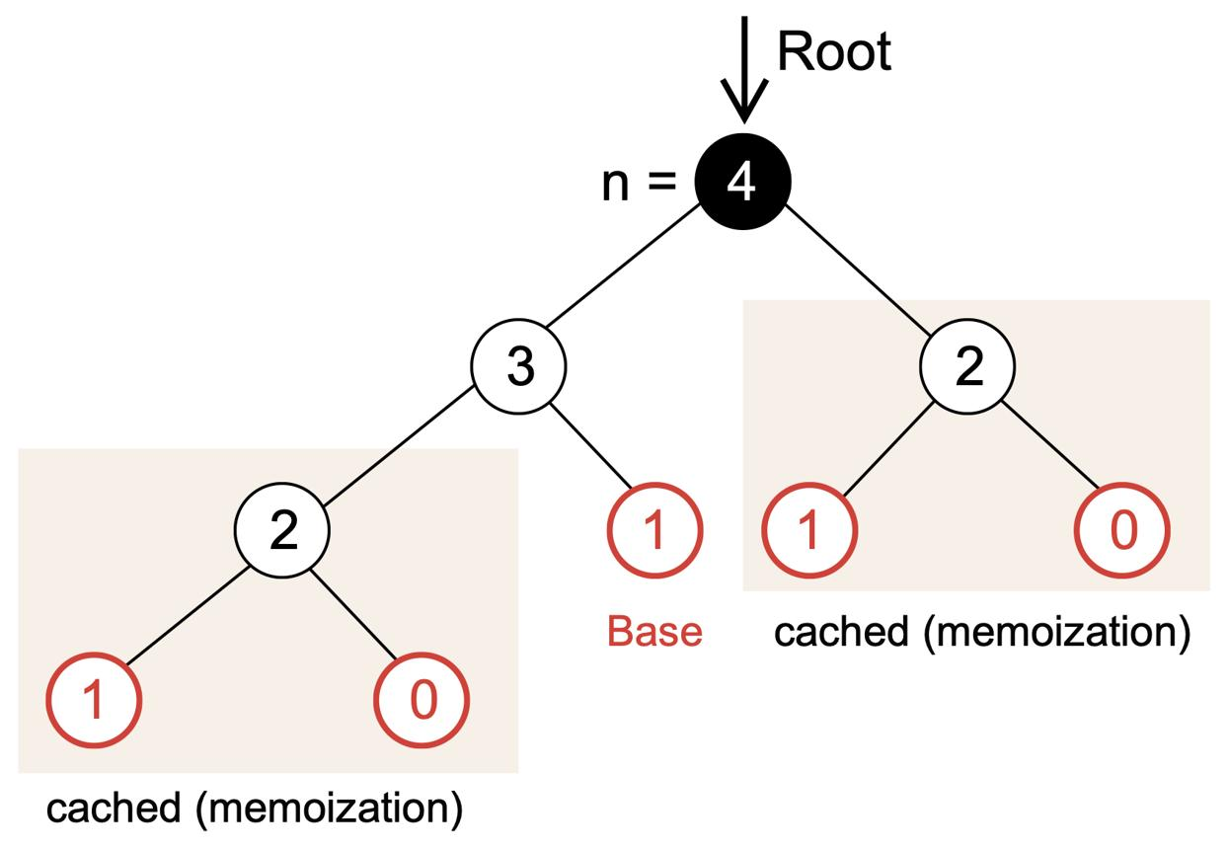
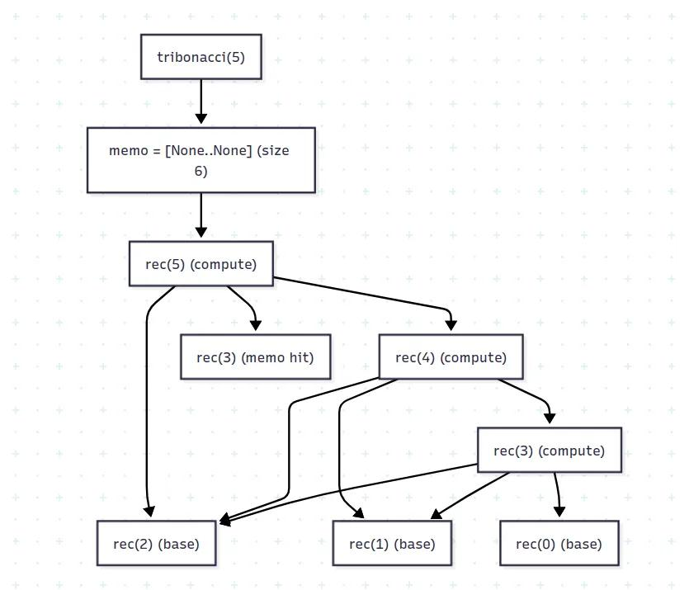
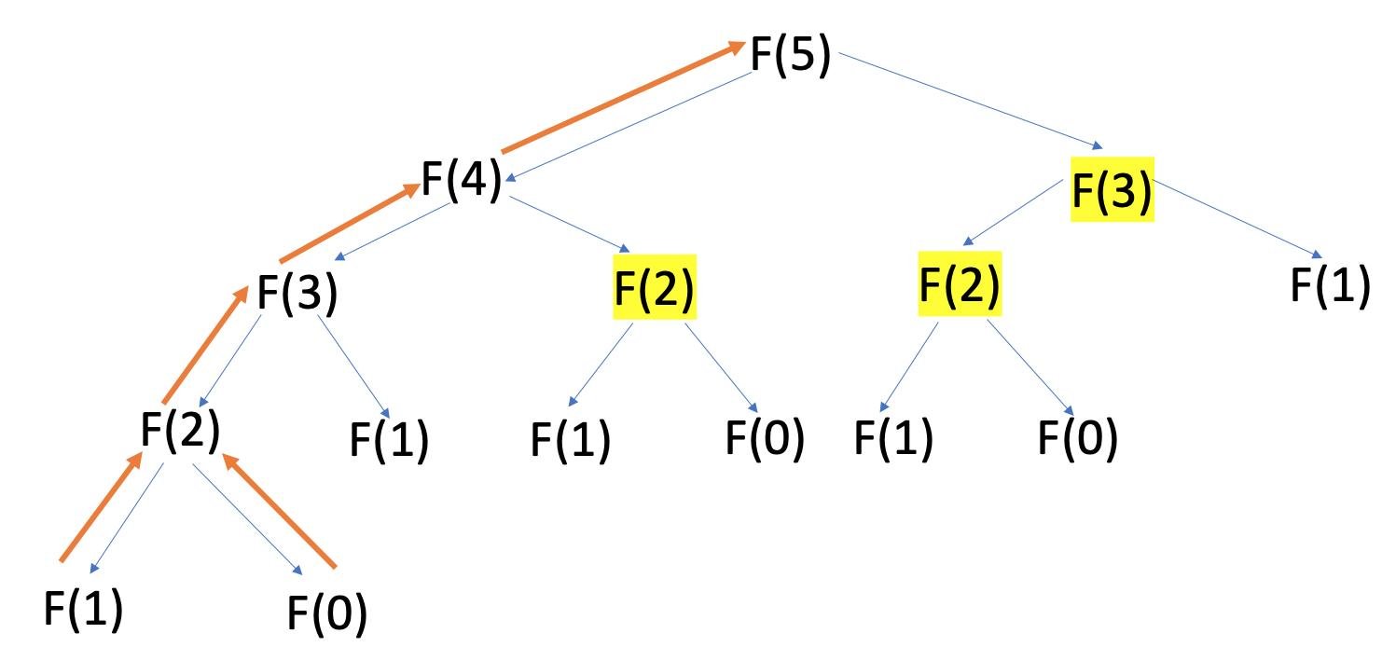
4

✅ Definition
Dynamic Programming is a technique to solve problems by breaking them into smaller overlapping subproblems and storing their results to avoid recomputation

📘 Core Idea
👉 “Solve once, store, reuse”
- Avoid repeated calculations
- Convert exponential → polynomial time
- Optimization over recursion

🎯 WHY DP IS NEEDED
- Recursion repeats same work
- DP stores results → faster solution
- Saves time and computation

🔑 PROPERTIES OF DP
✔ 1. Overlapping Subproblems
Same problem solved multiple times
✔ 2. Optimal Substructure
Optimal solution built from smaller optimal solutions

🔷 APPROACHES OF DP

🔹 1. Memoization (Top-Down)
⚙️ Working
- Use recursion
- Store results in table
📌 Steps
- Write recursive solution
- Create DP array
- Before computing → check DP
- Store result after computation

🔹 2. Tabulation (Bottom-Up)
⚙️ Working
- Solve from smallest problem
- Build solution iteratively
📌 Steps
- Define DP table
- Initialize base cases
- Fill table step by step
- Final answer at last cell

⚖️ Memoization vs Tabulation
Feature | Memoization | Tabulation
Approach | Top-down | Bottom-up
Method | Recursion | Iteration
Speed | Slightly slower | Faster
Space | More (stack) | Less

🔷 STEPS TO SOLVE DP PROBLEM (VERY IMPORTANT)
📌 Step-by-Step
- Identify DP problem
  - Optimization / counting
- Define State
  - Example: dp[n]
- Find Transition
  - Relation between states
- Base Case
  - Smallest solution
- Choose approach
  - Memoization / Tabulation

🔹 EXAMPLE: FIBONACCI

🔸 Recursive (Slow)
- TC: O(2ⁿ)

🔸 DP (Memoization)
fib(n):
if n <= 1:
return n
if dp[n] exists:
return dp[n]
dp[n] = fib(n-1) + fib(n-2)
return dp[n]

🔸 DP (Tabulation)
dp[0] = 0
dp[1] = 1
for i = 2 to n:
dp[i] = dp[i-1] + dp[i-2]

⏱ Time Complexity
- O(n)
💾 Space Complexity
- O(n)

🔷 POPULAR DP PROBLEMS
- Fibonacci
- Longest Common Subsequence
- Edit Distance
- Matrix Chain Multiplication
- Bellman-Ford
- Floyd Warshall

🔄 WITH vs WITHOUT DP
✔ With DP
- Fast (polynomial time)
- Avoids recomputation
❌ Without DP
- Exponential time
- Repeated calculations

✅ ADVANTAGES
- Efficient
- Reduces time complexity
- Solves complex problems

❌ DISADVANTAGES
- Hard to design
- Uses extra memory
- State definition tricky

🧠 FINAL MEMORY TRICK
👉 DP = Recursion + Storage

🧾 FINAL 5-LINE EXAM ANSWER
- DP solves overlapping subproblems
- Stores results to avoid recomputation
- Uses memoization or tabulation
- Reduces exponential → polynomial time
- Used in optimization problems

🧠 🔷 1. Fibonacci (DP Basics)
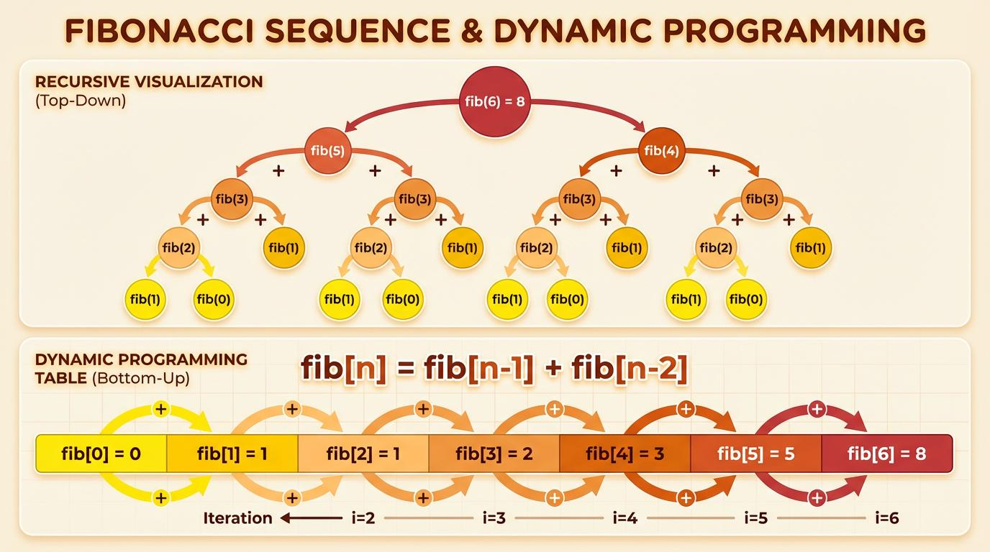
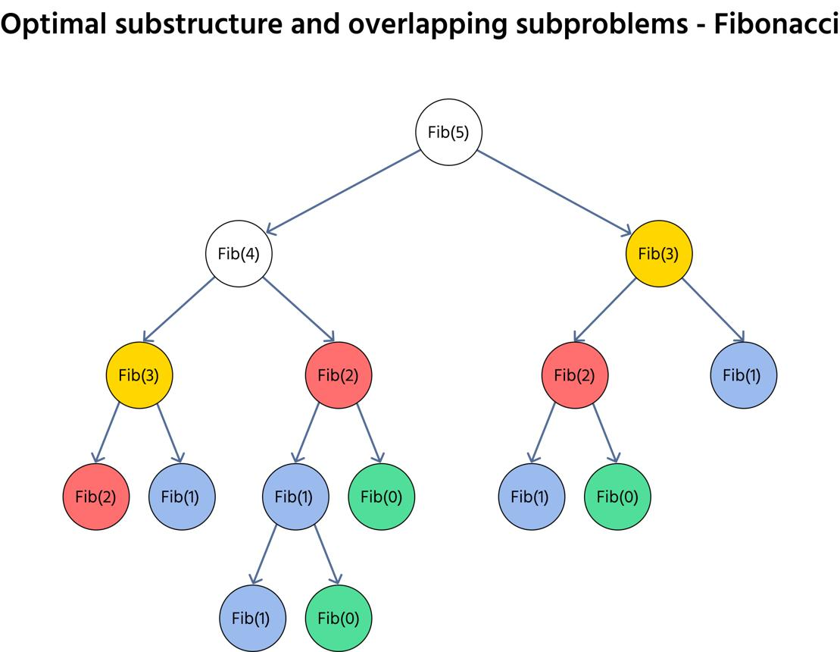
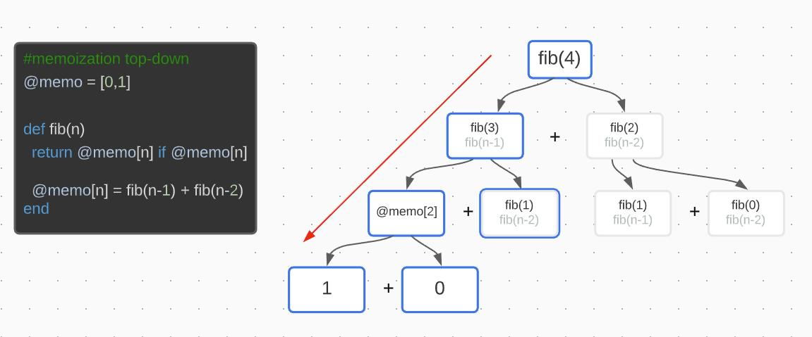
6
⚙️ State
dp[i] = ith Fibonacci
📌 Steps (Tabulation)
- dp[0] = 0, dp[1] = 1
- For i = 2 → n
- dp[i] = dp[i-1] + dp[i-2]
⏱ TC: O(n) | SC: O(n)

🧠 🔷 2. Longest Common Subsequence (LCS)
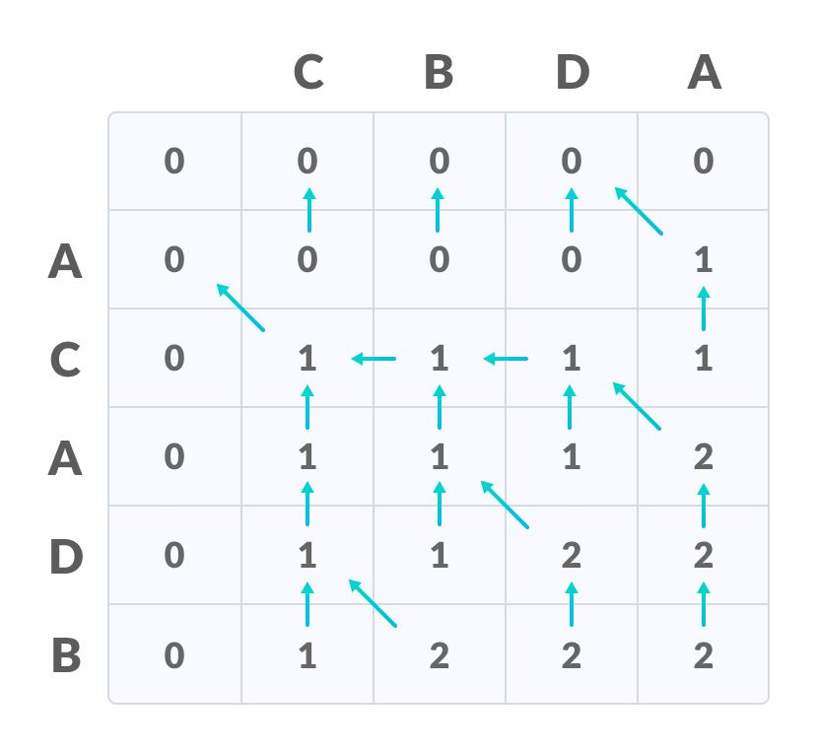
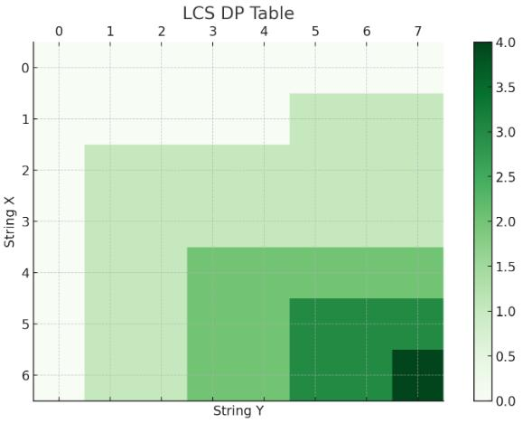
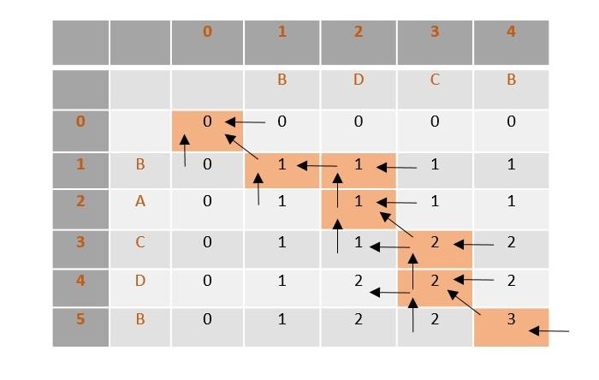
6
⚙️ State
dp[i][j] = LCS of first i and j characters
📌 Steps
- Initialize dp with 0
- If characters match:
dp[i][j] = 1 + dp[i-1][j-1]
- Else:
dp[i][j] = max(dp[i-1][j], dp[i][j-1])
⏱ TC: O(nm) | SC: O(nm)

🧠 🔷 3. Edit Distance
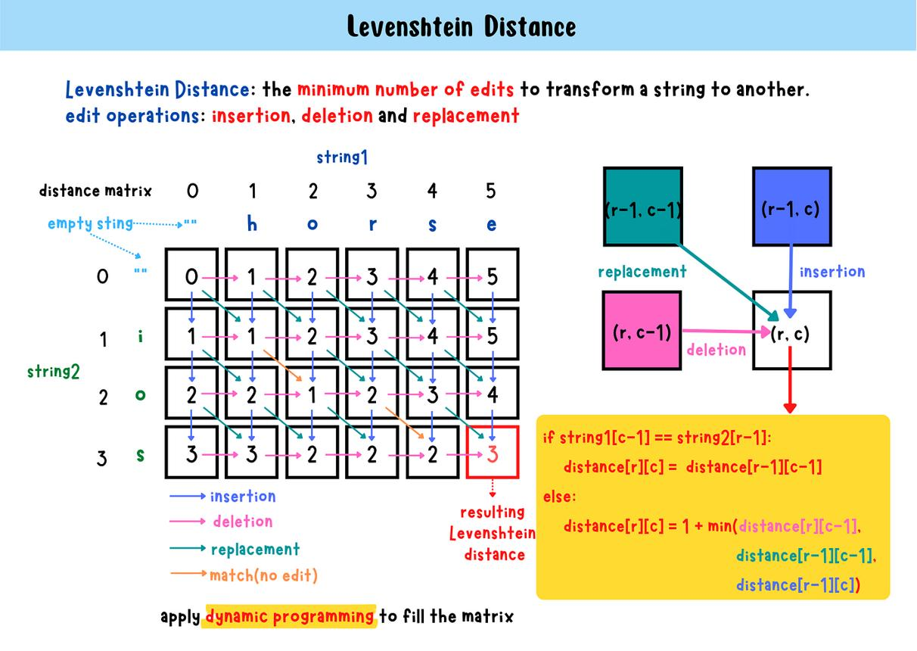
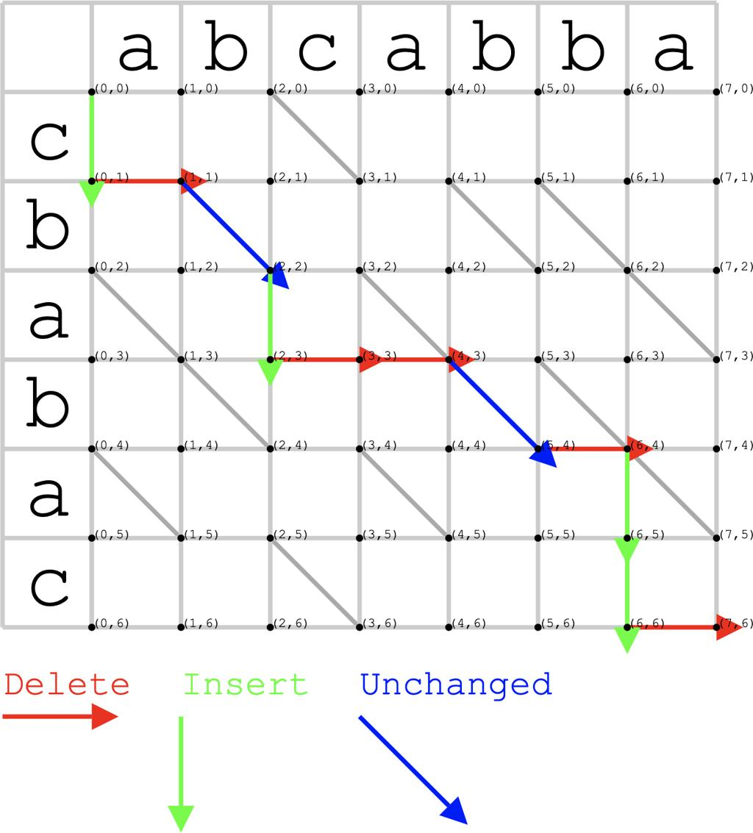
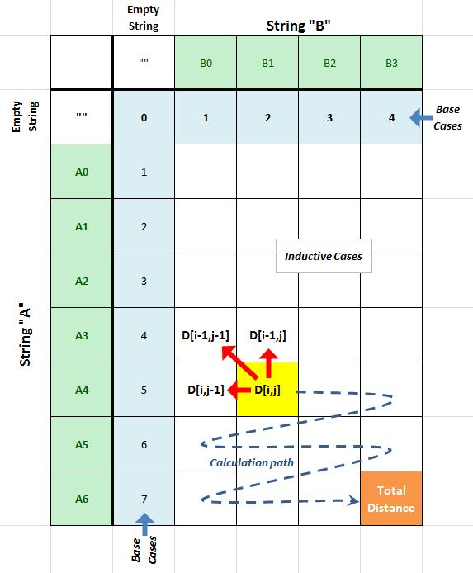
6
⚙️ State
dp[i][j] = min operations to convert string1 → string2
📌 Steps
- Initialize first row & column
- If match → dp[i][j] = dp[i-1][j-1]
- Else →
min(insert, delete, replace)
⏱ TC: O(n*m)

🧠 🔷 4. Matrix Chain Multiplication
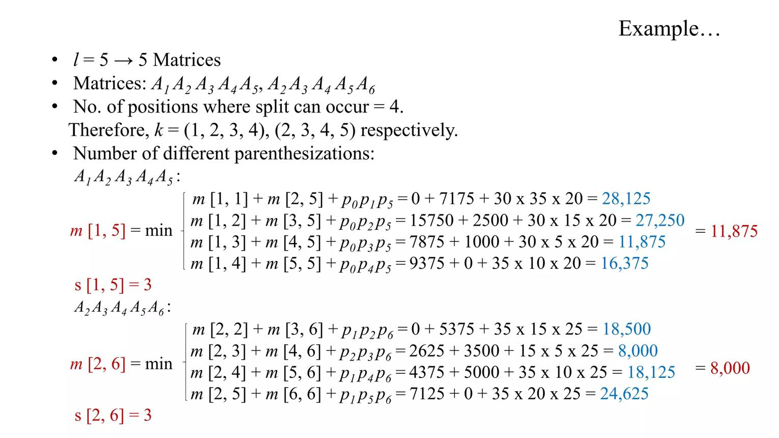
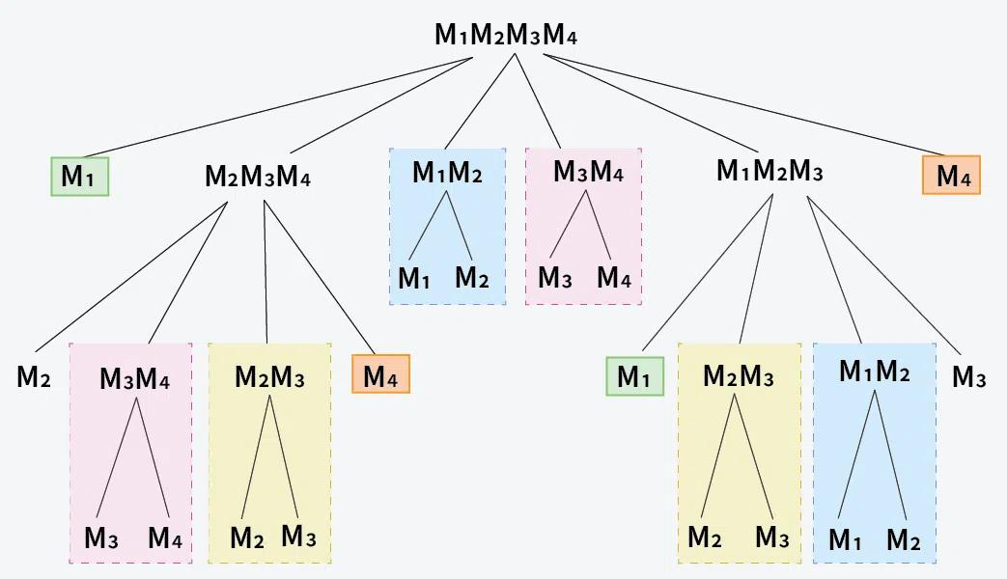
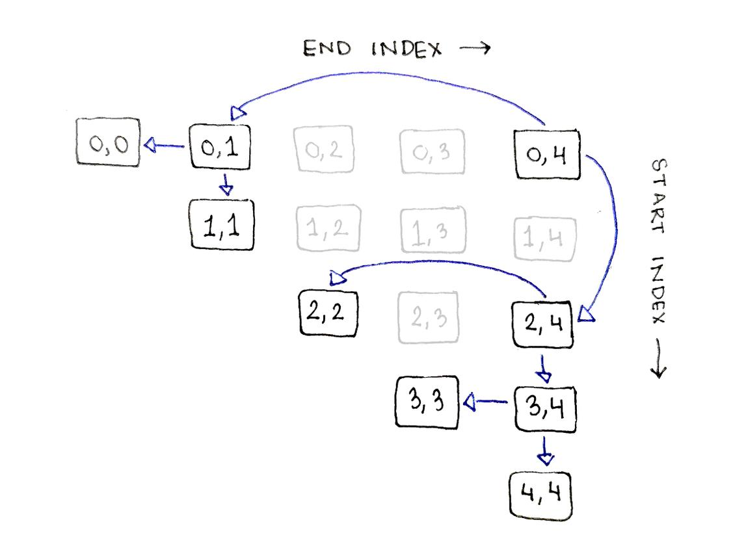
7
⚙️ State
dp[i][j] = minimum cost of multiplying matrices i to j
📌 Steps
- Initialize diagonal = 0
- Try all k between i and j
- dp[i][j] = min cost
⏱ TC: O(n³)

🧠 🔷 5. Bellman-Ford (DP + Graph)
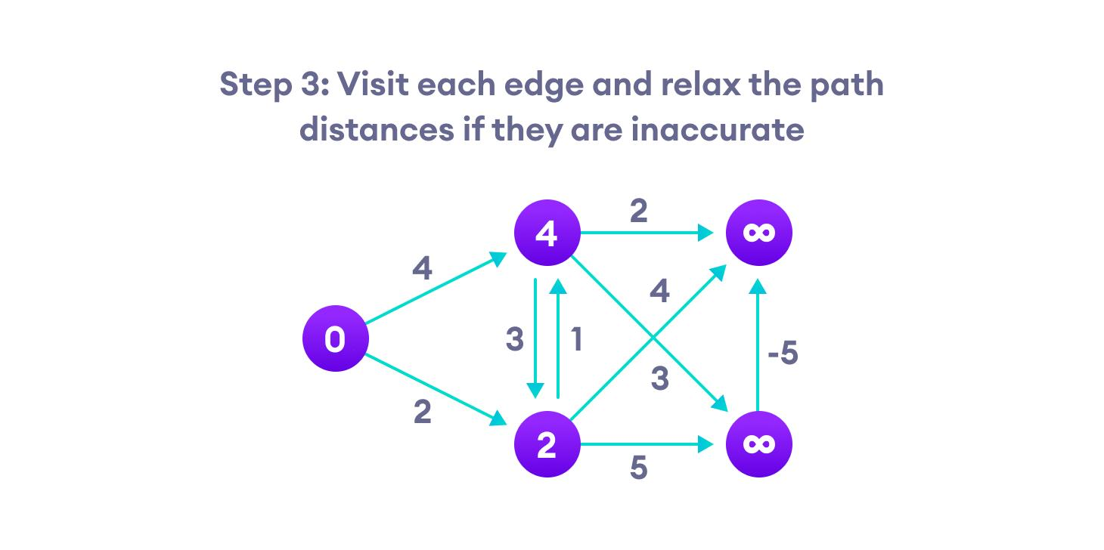
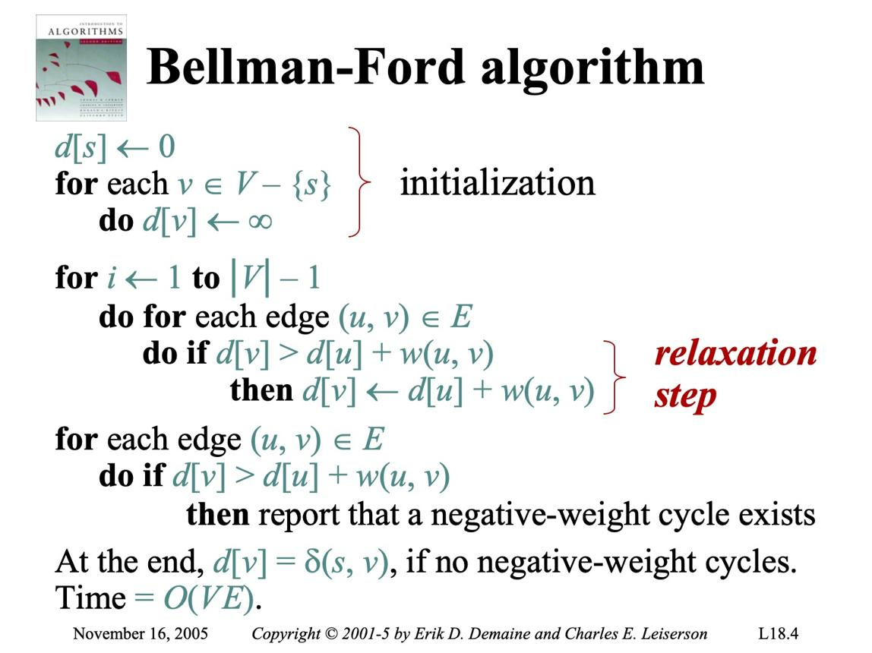
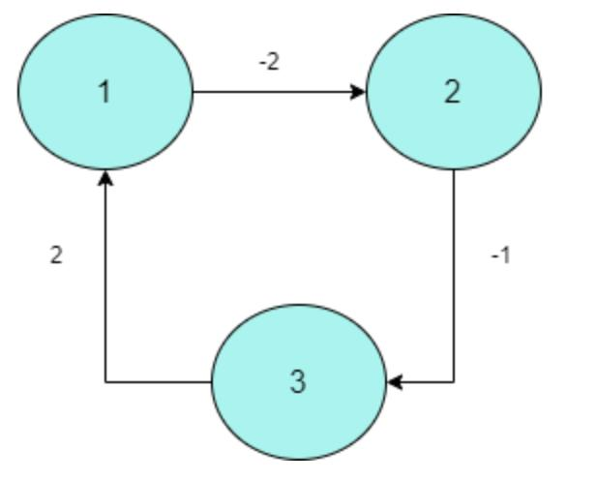
6
⚙️ Idea
Relax edges repeatedly
📌 Steps
- Initialize distances
- Repeat V-1 times:
update all edges
- Check negative cycle
⏱ TC: O(VE)

🧠 🔷 6. Floyd Warshall (DP Matrix)
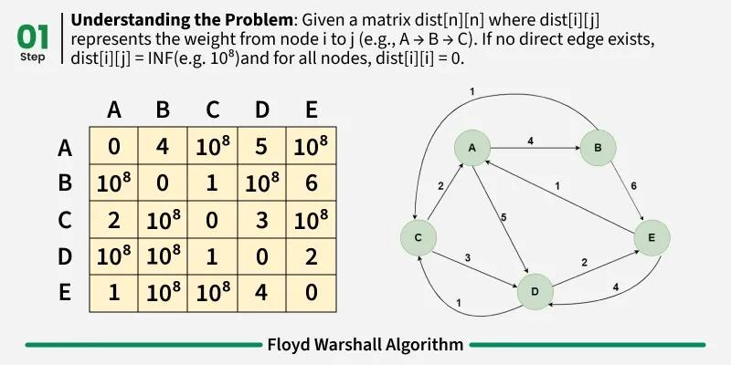
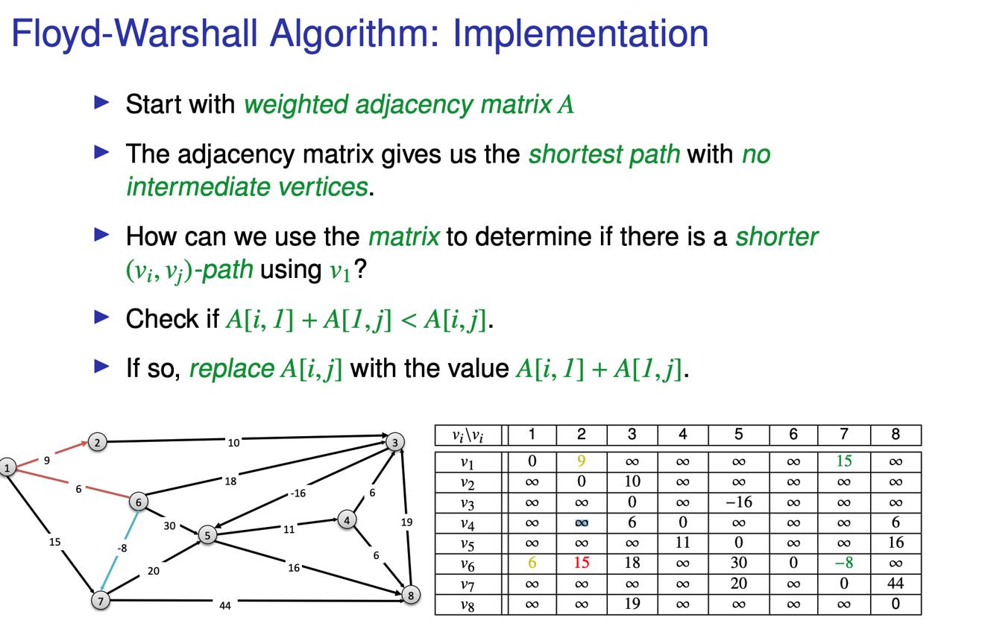
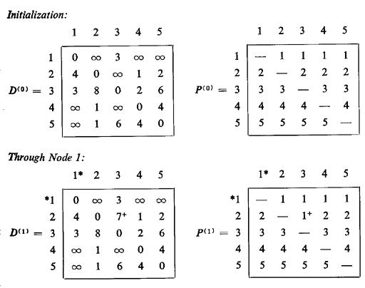
5
⚙️ State
dp[i][j] = shortest path from i to j
📌 Steps
For each k:
dp[i][j] = min(dp[i][j], dp[i][k] + dp[k][j])
⏱ TC: O(n³)

🔥 IMPORTANT DP PATTERNS

🔹 1. Knapsack Pattern
⚙️ State
dp[i][w] = max value using i items and weight w
📌 Steps
- If weight <= capacity → include
- Else → exclude
- Take max
👉 Used in: 0/1 Knapsack

🔹 2. LCS Pattern
- Matching → diagonal
- Not matching → max of left/top
👉 Used in:
- LCS
- Edit Distance

🔹 3. Subsequence Pattern
- Include / Exclude choice
- Recursive decision

🔹 4. Partition Pattern
- Split at k
- Try all partitions
👉 Used in:
- Matrix Chain
- Palindrome Partition

🔹 5. DP on Graph
- Relax edges
- Update distances
👉 Used in:
- Bellman-Ford
- Floyd Warshall

🧠 FINAL QUICK MEMORY
Problem | Pattern
Fibonacci | 1D DP
LCS | 2D DP
Edit Distance | 2D DP
MCM | Partition DP
Bellman | Graph DP
Floyd | Matrix DP

🧾 FINAL EXAM STRATEGY
👉 Always write:
- State definition
- Recurrence relation
- Base case
- Table filling

🧠 FINAL 5-LINE SUMMARY
- DP stores subproblem results
- Avoids recomputation
- Uses memoization/tabulation
- Based on optimal substructure
- Reduces exponential → polynomial

